Politehnica University of Bucharest

Software Engineering
PROJECT
Software Design Document
Team:  Sakka Mohamad-Mario  Coordinator:  N/A | Date created:  15.11 .2025

DELIVERY REPORT

Name Group Project implementation [%, reason] Signature
Sakka Mohamad-
Mario 1241EB ____________________________
____________________________
____________________________

Delivery date:
__________________________________

Table of Contents
Politehnica University of Bucharest 1
Software Engineering 1
DELIVERY REPORT 2
SYSTEM DESIGN 5
Document Change History 5
1.1. Purpose 5
1.2. Target Public 5
1.3. Definitions, Acronyms and Abbreviations 5
1.4. Document Structure 6
2. References 7
3. Decomposition Description 8
3.1. Modules Description 8
3.1.1. Description of Module 1 8
3.1.2. Description of Module 2 8
3.2. Description of Concurrent Processes 9
3.2.1. Description of Process 1 9
3.2.2. Description of Process 2 10
3.2.3. Description of Process 3 10
3.3. Description of Data Modules 11
3.3.1. Description of Data Module 1 11
3.3.2. Description of Data Module 2 12
3.3.3. Description of Data Module 3 12
3.3.4. Description of Data Module 4 13
3.3.5. Description of Data Module 5 13
3.3.6. Description of Data Module 6 14
4. Dependency Description 15
4.1. Dependencies among modules 15
4.2. Dependencies among processes 16
4.3. Dependencies among data modules 17
5. Interface Description 18
5.1. Module Interfaces 18
5.1.1. Module 1 Interface — BackendAPI (Express) 18
5.1.2. Module 2 Interface — GenerateRecipeService (Android) 19
5.1.3. Module 3 Interface — DatabaseBackgroundService (Android) 19
5.1.4. Module 4 Interface — SharedPreferencesManager (Android) 20
5.1.5. Module 5 Interface — RandomQuoteWorker (Android) 21
5.1.6. Module 6 Interface — RecipeDao (Room) 21
5.1.7. Module 7 Interface — IngredientDao (Room) 22
5.2. Processes Interfaces 22
5.2.1. Process 1 Interface — GenerateRecipesForegroundProcess 22
5.2.2. Process 2 Interface — QuotesPeriodicProcess 23
5.2.3. Process 3 Interface — DBConsistencyProcess 24
6. Detailed Design 25
6.1. Modules detailed design 25
6.1.1. Module 1 — MobileApp (Android/Kotlin) 25
6.1.2. Module 2 — BackendAPI (Node/Express) 30
6.2. Data Modules Detailed Design 31
6.2.1. Data module 1 — RecipeEntity 31
6.2.2. Data module 2 — IngredientEntity 33
6.2.3 Data module 3 — Recipe (model) 34
6.2.4 Data module 4 — Ingredient (model) 35
6.2.5 Data module 5 — RecipeDao (DAO) 35
6.2.6 Data module 6 — IngredientDao (DAO) 37
Appendices 39
A1. Use cases diagrams 39
A2. Class diagrams 40
A3. Sequence diagrams 43
A4. Document evolution 47
A5. Conclusions regarding the activity 47

SYSTEM DESIGN
According to the IEEE STD-1016-1998, IEEE Recommended Practice for Software Design Descriptions.

Document Change History
Version | Date | Author(s) | Details of changes
1.14 | 2025-11-16 | Sakka Mohamad‑Mario | Table headers bold throughout; reference access dates set between 05–10 Nov 2025.
1.13 | 2025-11-16 | Sakka Mohamad‑Mario | Reformatted all modules/classes/interfaces/processes to tables per template; diagrams as PlantUML.
1.12 | 2025-11-16 | Sakka Mohamad‑Mario | Expanded Section 4; exact formatting for Sections 5 & 6; full references.
1.10 | 2025-11-16 | Sakka Mohamad‑Mario | Initial full-code SDD (Android + Node server).
1.00 | 2025-10-15 | Sakka Mohamad‑Mario | Initial baseline based on SRS + partial code.

1.1. Purpose
State the purpose of this document: the presentation of the design of a system that solves the requirements of the proposed project. This SDD reflects the **actual** code in the Android client (Kotlin) and the Node/Express backend, including Room entities/DAOs, background services, WorkManager, Retrofit HTTP client, and server routes.

1.2. Target Public
Describe the people that this document is addressed to: programmers, designers, and project managers working on RecipeGPT. The client/end‑user is not part of the target public.

1.3. Definitions, Acronyms and Abbreviations
Field | Description
API | Application Programming Interface
APK/AAB | Android application package / app bundle
CI/CD | Continuous Integration / Continuous Deployment
DAO | Data Access Object (Room)
DB | Database (Room/SQLite)
DTO | Data Transfer Object
GCP | Google Cloud Platform
JSON | JavaScript Object Notation
LLM | Large Language Model
Room | Android persistence library
TLS/HTTPS | Transport Layer Security / HTTPS
UoM | Unit of Measure (grams, ml, pcs)
WorkManager | Android background scheduler

1.4. Document Structure
Chapter 1 – Introduction
Presents the purpose of the system and this document, the intended audience, key terminology, and an overview of how the SDD is organized.
Chapter 2 – References
Lists the standards, official documentation, and external resources that were used when designing and documenting RecipeGPT.
Chapter 3 – Decomposition Description
Describes how the system is broken down into modules, concurrent processes, and data modules, giving a conceptual map of the overall architecture.
Chapter 4 – Dependency Description
Details the dependencies and interactions between modules, processes, and data modules, including how they cooperate at runtime.
Chapter 5 – Interface Description
Specifies the interfaces of the main modules and processes, including their inputs, outputs, and observable behavior, in a more formal and precise way.
Chapter 6 – Detailed Design
Provides the low-level design of modules and data structures, including classes, methods, algorithms, and internal responsibilities.
Appendices
Contain supporting material such as use case diagrams, class and sequence diagrams, document evolution notes, and a short conclusion on the design activity.

2. References
[1] IEEE Std 1016-1998. IEEE Recommended Practice for Software Design Descriptions. IEEE. https://cs.bilkent.edu.tr/~cagatay/cs413/1016-1998_00741934.pdf (Accessed: 05 Nov 2025).
[2] Getting started with WorkManager. Android Developers. https://developer.android.com/develop/background-work/background-tasks/persistent/getting-started (Accessed: 06 Nov 2025).
[3] WorkManager API reference. Android Developers. https://developer.android.com/reference/androidx/work/WorkManager (Accessed: 07 Nov 2025).
[4] Save data in a local database using Room. Android Developers. https://developer.android.com/training/data-storage/room/ (Accessed: 08 Nov 2025).
[5] Define data using Room entities. Android Developers. https://developer.android.com/training/data-storage/room/defining-data (Accessed: 09 Nov 2025).
[6] Foreground services overview. Android Developers. https://developer.android.com/develop/background-work/services/fgs (Accessed: 10 Nov 2025).
[7] Retrofit — A type-safe HTTP client for Android and Java. Square (GitHub). https://github.com/square/retrofit (Accessed: 05 Nov 2025).
[8] OkHttp — Square’s HTTP client. Square (GitHub). https://github.com/square/okhttp (Accessed: 06 Nov 2025).
[9] Express — Node.js web application framework. Express.js. https://expressjs.com/ (Accessed: 07 Nov 2025).
[10] Node.js Documentation. Node.js. https://nodejs.org/api/all.html (Accessed: 08 Nov 2025).
[11] Cloud Run documentation. Google Cloud. https://docs.cloud.google.com/run/docs (Accessed: 09 Nov 2025).
[12] GitHub Actions documentation. GitHub Docs. https://docs.github.com/en/actions (Accessed: 10 Nov 2025).
[13] Workflow syntax for GitHub Actions. GitHub Docs. https://docs.github.com/en/actions/reference/workflows-and-actions/workflow-syntax (Accessed: 05 Nov 2025).

3. Decomposition Description

3.1. Modules Description

3.1.1. Description of Module 1
Field | Description
Name | MobileApp (Android/Kotlin)
Type | Code module
Purpose | Provide UI/UX; orchestrate recipe generation; local persistence; notifications.
Way of operating | Activities host navigation; Fragments+ViewModels manage state; Services execute work; Room for persistence; WorkManager for periodic jobs; Retrofit/OkHttp for HTTP.
Subordination | Activities (HomeActivity, RecipeDetailsActivity); Services (GenerateRecipeService, DatabaseBackgroundService, SearchNotificationForegroundService); Worker (RandomQuoteWorker); Data (AppDatabase, RecipeEntity, IngredientEntity; RecipeDao, IngredientDao); Network (ApiClient, ApiInterface); Utils (NotificationUtils, SharedPreferencesManager); Adapters (RecipeAdapter, etc.).
Dependencies | Android SDK; Room; Retrofit/OkHttp; WorkManager; LocalBroadcastManager; Notifications.
Resources | SQLite (Room), Notification channels, Internet

3.1.2. Description of Module 2
Field | Description
Name | BackendAPI (Node/Express)
Type | Process / Code module
Purpose | Validate inputs; call OpenAI; return JSON schemas for recipes and random quotes.
Way of operating | Express GET endpoints with query parameters; JSON responses; invokes OpenAI client using schema-guided prompts.
Subordination | server.js (route handlers); schemas.js (JSON schemas); env config (.env); OpenAI client.
Dependencies | Node.js; Express; OpenAI API; dotenv; HTTPS.
Resources | Node 18+, network connectivity, API key

3.2. Description of Concurrent Processes

3.2.1. Description of Process 1
Field | Description
Name | GenerateRecipesForegroundProcess
Type | Process
Purpose | Keep UI responsive during recipe generation; show persistent progress; handle timeouts/errors.
Way of operating | UI → ViewModel → bind GenerateRecipeService → dynamic timeout call → callback on main thread → stop foreground.
Dependencies | Backend availability; Permissions & channel for notifications
Resources | Foreground service notification; Retrofit client

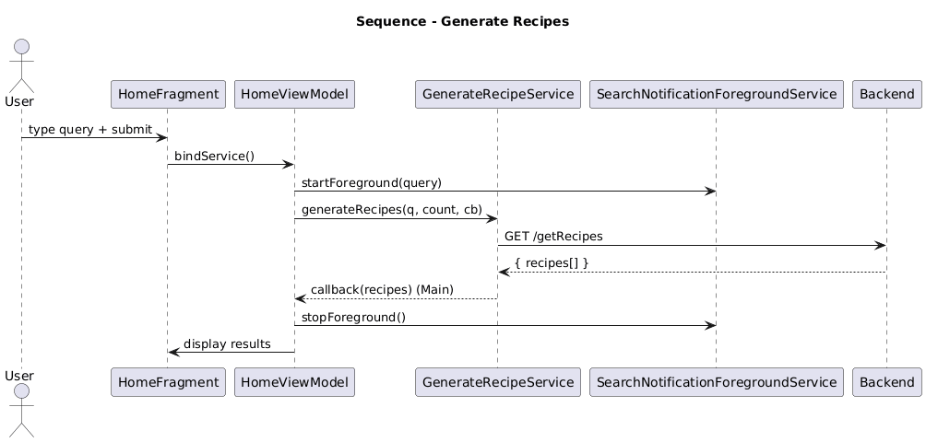

3.2.2. Description of Process 2
Field | Description
Name | QuotesPeriodicProcess
Type | Process
Purpose | Periodically fetch and display a random cooking quote.
Way of operating | WorkManager runs RandomQuoteWorker; Retrofit call; show success/error notification.
Dependencies | Notification channel; preferences-driven schedule
Resources | Worker runtime; Retrofit client

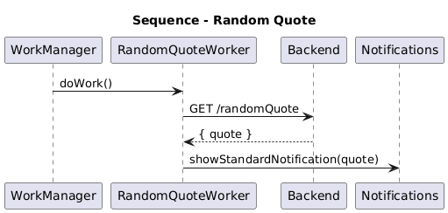

3.2.3. Description of Process 3
Field | Description
Name | DBConsistencyProcess
Type | Process
Purpose | Encapsulate DB operations and enforce consistency rules (save/update, canCook, cook).
Way of operating | UI sends Intent to DatabaseBackgroundService; DAO calls on IO; reply via ResultReceiver; broadcast LOCAL_DB_CHANGED
Dependencies | Room (RecipeDao, IngredientDao); UnitConverter
Resources | SQLite, LocalBroadcastManager

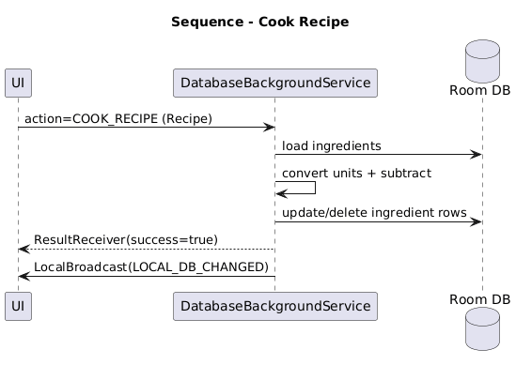

3.3. Description of Data Modules

3.3.1. Description of Data Module 1
Field | Description
Name | RecipeEntity
Type | Data module (Room Entity, table 'recipes')
Purpose | Persist generated/saved recipes and the listed-for-shopping flag.
Way of operating | Accessed via RecipeDao; complex fields (ingredients, instructions) serialized with Gson TypeConverters.
Subordination | Declared in AppDatabase.entities; used by DatabaseBackgroundService via RecipeDao.
Dependencies | Room; GsonConverters; models.Recipe; models.Ingredient
Resources | SQLite (Room)

Field | Type | Notes
title | String | PRIMARY KEY; unique recipe identifier
estimatedCookingTime | Int | Minutes
servings | Int | Suggested servings
listed | Boolean | Shopping-list marker
ingredients | List<Ingredient> | Serialized via GsonConverters
instructions | List<String> | Serialized via GsonConverters

3.3.2. Description of Data Module 2
Field | Description
Name | IngredientEntity
Type | Data module (Room Entity, table 'ingredients', composite PK: item+unit)
Purpose | Persist inventory items with per-unit quantities to support cooking and shopping flows.
Way of operating | Accessed via IngredientDao; names normalized (lowercase) at insert; unit conversions handled at service layer.
Subordination | Declared in AppDatabase.entities; used by DatabaseBackgroundService via IngredientDao.
Dependencies | Room; models.Ingredient; UnitConverter (at call sites)
Resources | SQLite (Room)

Field | Type | Notes
item | String | Composite PK (part); lowercased
unit | String | Composite PK (part); UoM label
amount | Double | Quantity in given unit; non-negative

3.3.3. Description of Data Module 3
Field | Description
Name | Recipe (model)
Type | Data module (Domain model)
Purpose | In-memory representation of a recipe used by UI and services.
Way of operating | Mapped to/from RecipeEntity; transported via Intents/ResultReceiver bundles.
Subordination | Used by UI, GenerateRecipeService, DatabaseBackgroundService.
Dependencies | models.Ingredient; RecipeEntity (mapping)
Resources | RAM (in-memory)

3.3.4. Description of Data Module 4
Field | Description
Name | Ingredient (model)
Type | Data module (Domain model)
Purpose | In-memory representation of an inventory item with amount and unit.
Way of operating | Mapped to/from IngredientEntity; used in canCook/cook logic.
Subordination | Used by UI and DatabaseBackgroundService.
Dependencies | QuantUnit (via UnitConverter at call sites)
Resources | RAM (in-memory)

3.3.5. Description of Data Module 5
Field | Description
Name | RecipeDao
Type | Data module (Data Access Object, Room DAO)
Purpose | Provide CRUD operations for RecipeEntity.
Way of operating | Suspend functions executed on IO dispatcher; used by DatabaseBackgroundService.
Subordination | Exposed by AppDatabase.recipeDao()
Dependencies | Room; RecipeEntity
Resources | SQLite (Room)

3.3.6. Description of Data Module 6
Field | Description
Name | IngredientDao
Type | Data module (Data Access Object, Room DAO)
Purpose | Provide CRUD operations for IngredientEntity.
Way of operating | Suspend functions executed on IO dispatcher; used by DatabaseBackgroundService.
Subordination | Exposed by AppDatabase.ingredientDao()
Dependencies | Room; IngredientEntity
Resources | SQLite (Room)

4. Dependency Description

4.1. Dependencies among modules
Origin | Target | Contract / API | Direction | Sync/Async | Failure modes | Handling & Notes
HomeActivity | NotificationUtils | Permission & Channel creation | → | Sync | Permission denied; channel missing | Toast and channel creation at startup
UI (Fragments/ViewModels) | GenerateRecipeService | Binder + Kotlin callback | → | Async (callback on Main) | Timeout; HTTP errors | Dynamic timeout; notifications; empty list on non-200
UI (Fragments/ViewModels) | DatabaseBackgroundService | Intent + ResultReceiver + LocalBroadcast | ↔ | Async | DB contention; null inputs | IO dispatcher; broadcast DB_CHANGED
SharedPreferencesManager | RandomQuoteWorker | ACTION_SETTINGS_UPDATED broadcast | → | Async | Out-of-date schedule | Reschedule worker
RandomQuoteWorker | Backend | Retrofit GET /randomQuote | → | Sync | Timeout; 4xx/5xx | 10s timeout; error notification
GenerateRecipeService | Backend | Retrofit GET /getRecipes | → | Sync | Timeout; 4xx/5xx | 5s + 10s/recipe (≤120s); error notifications
DatabaseBackgroundService | RecipeDao | Room DAO | → | Sync | Constraint errors | REPLACE insert; targeted deletes
DatabaseBackgroundService | IngredientDao | Room DAO | → | Sync | Unit mismatch | UnitConverter.convert/add; normalize unit
Express Server | OpenAI | HTTPS | → | Sync/Async | 429/5xx | Backoff/retry (impl dependent)

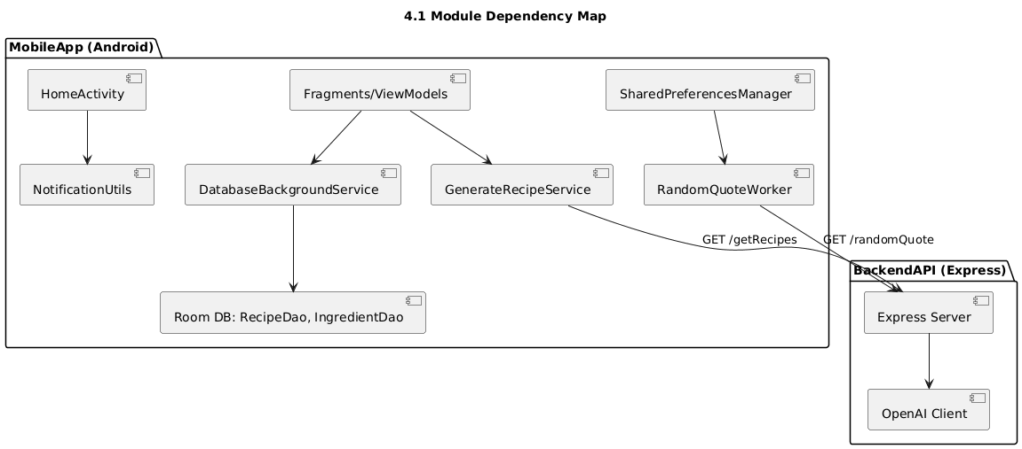

4.2. Dependencies among processes
Process | Trigger | Relies on | Sync points | Timeouts/Backoff | Cancellation/Stop | Observability
GenerateRecipesForegroundProcess | User submits query | Service binding; Retrofit; Notifications | Callback on main | 5s + 10s/recipe (≤120s) | Stop foreground on end | Persistent notif + UI flags
QuotesPeriodicProcess | WorkManager schedule | Retrofit; Notifications; Prefs | doWork() result | ~10s default timeout | WorkManager reschedule | Notification message
DBConsistencyProcess | UI Intent actions | Room DAOs; UnitConverter | ResultReceiver | N/A | N/A | LOCAL_DB_CHANGED broadcast

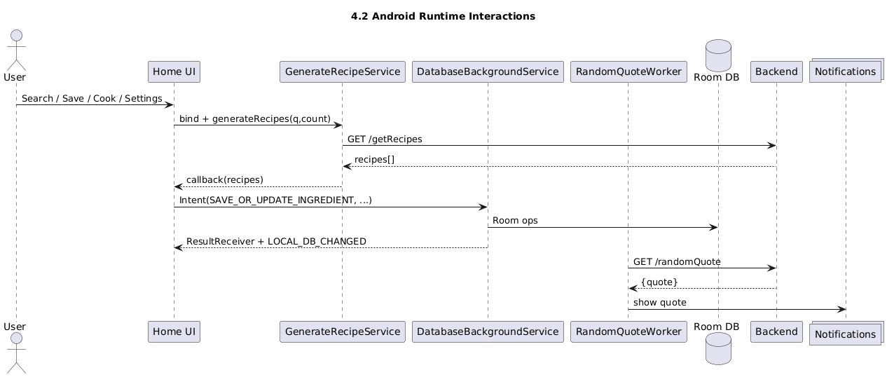

4.3. Dependencies among data modules
Data module | Depends on | Nature | Notes
RecipeEntity | Ingredient (embedded list) | Containment | Stored via GsonConverters
IngredientEntity | UnitConverter | Computation | Normalization and addition across units
DAOs | Room/SQLite | Storage | Suspend functions, IO dispatcher

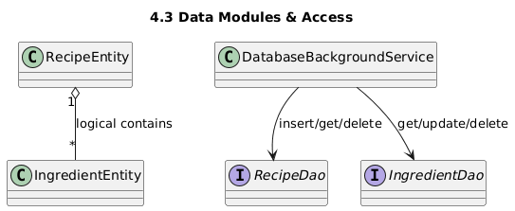

5. Interface Description
This chapter corresponds to chapter 6.2.3, Interface description, from [1].

5.1. Module Interfaces

5.1.1. Module 1 Interface — BackendAPI (Express)
Field | Description
Name | BackendAPI (Express)
Type | Process / Code module
Purpose | Provide HTTP endpoints to generate recipes and fetch a random quote
Way of operating | Express handlers respond to GET requests with JSON; server calls OpenAI

Interface 1 — GET /getRecipes(numberOfRecipes, recipeQuery)
Input | Output | Description
numberOfRecipes:int; recipeQuery:string (query parameters over HTTPS) | { recipes: Array<Recipe> } | Validate → OpenAI → normalize → JSON

Interface 2 — GET /randomQuote()
Input | Output | Description
— | { quote: string } | Return concise quote JSON

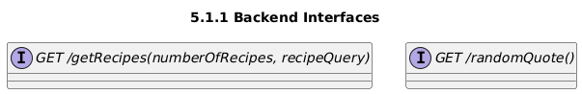

5.1.2. Module 2 Interface — GenerateRecipeService (Android)
Field | Description
Name | GenerateRecipeService
Type | Code module / Service (bound)
Purpose | Execute recipe generation with dynamic timeout and notify on errors
Way of operating | Bound from UI; network call on IO; result via callback on main; notifications for timeouts/errors

Interface — result generateRecipes(query:String, numberOfRecipes:Int, callback:(List<Recipe>) -> Unit)
Input | Output | Description
query:String; numberOfRecipes:Int | callback receives List<Recipe> | Timeout = 5s + 10s/recipe (≤120s); Retrofit → GET /getRecipes; exceptions → NotificationUtils

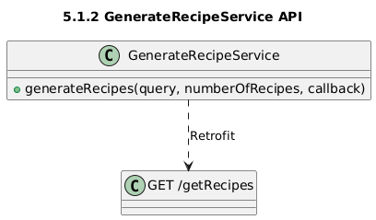

5.1.3. Module 3 Interface — DatabaseBackgroundService (Android)
Field | Description
Name | DatabaseBackgroundService
Type | Code module / Service (background)
Purpose | Serialize DB operations and enforce domain rules; IPC via Intents/ResultReceiver
Way of operating | onStartCommand routes actions; Room on IO; broadcasts LOCAL_DB_CHANGED

Action (Interface) | Input | Output / Description
GET_SAVED_RECIPES | — | ArrayList<Recipe> (Bundle key "data")
GET_RECIPE_BY_NAME | name:String | Recipe? ("data")
SAVE_OR_REPLACE_RECIPE | recipe:Recipe | — ; broadcast LOCAL_DB_CHANGED
DELETE_RECIPE_BY_NAME | name:String | — ; broadcast LOCAL_DB_CHANGED
GET_SAVED_INGREDIENTS | — | ArrayList<Ingredient> ("data")
GET_INGREDIENT_BY_NAME_AND_UNIT | name:String, unit:String | Ingredient? ("data")
SAVE_OR_UPDATE_INGREDIENT | ingredient:Ingredient | merge & normalize; broadcast LOCAL_DB_CHANGED
DELETE_INGREDIENT_BY_NAME_AND_UNIT | name:String, unit:String | — ; broadcast LOCAL_DB_CHANGED
FETCH_LISTED_RECIPES | — | ArrayList<Recipe> ("recipes")
CAN_COOK_RECIPE | recipe:Recipe | canCook:Boolean; missing_ingredients:ArrayList<Ingredient>
COOK_RECIPE | recipe:Recipe | success:Boolean ; broadcast LOCAL_DB_CHANGED

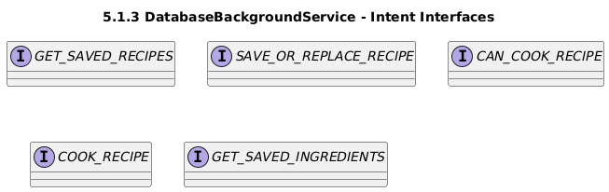

5.1.4. Module 4 Interface — SharedPreferencesManager (Android)
Field | Description
Name | SharedPreferencesManager
Type | Code module / Utility
Purpose | Persist settings and broadcast ACTION_SETTINGS_UPDATED with extras
Way of operating | SharedPreferences writes followed by LocalBroadcast broadcast

getRandomQuoteFrequency()
Input | Output | Description
— | String (default "15 minutes") | Returns current frequency

saveRandomQuoteFrequency(frequency:String)
Input | Output | Description
frequency:String | — | Persists + broadcasts

getMaxResults()
Input | Output | Description
— | Int (default 10) | Returns current max results

saveMaxResults(maxResults:Int)
Input | Output | Description
maxResults:Int | — | Persists + broadcasts

5.1.5. Module 5 Interface — RandomQuoteWorker (Android)
Field | Description
Name | RandomQuoteWorker
Type | Code module / Worker
Purpose | Fetch and notify a random quote at scheduled intervals
Way of operating | WorkManager calls doWork(); Retrofit GET with ~10s timeout; notification on success/error

doWork(): Result
Input | Output | Description
— | Result.success() | Shows notification, returns success

5.1.6. Module 6 Interface — RecipeDao (Room)
Method | Input | Output | Notes
getAllRecipesSync() | — | List<RecipeEntity> | Suspend function
getRecipeByNameSync(name) | name:String | RecipeEntity? | Suspend function
getListedRecipes() | — | List<RecipeEntity> | listed=1
insertRecipe(recipe) | recipe:RecipeEntity | Unit | OnConflictStrategy.REPLACE
deleteRecipeByName(name) | name:String | Unit | —

5.1.7. Module 7 Interface — IngredientDao (Room)
Method | Input | Output | Notes
getAllIngredientsSync() | — | List<IngredientEntity> | Suspend function
getIngredientByNameAndUnitSync(name,unit) | name:String, unit:String | IngredientEntity? | Suspend function
insertIngredient(ingredient) | ingredient:IngredientEntity | Unit | OnConflictStrategy.REPLACE
updateIngredient(ingredient) | ingredient:IngredientEntity | Unit | —
deleteIngredientByNameAndUnit(name,unit) | name:String, unit:String | Unit | —

5.2. Processes Interfaces

5.2.1. Process 1 Interface — GenerateRecipesForegroundProcess
Field | Description
Trigger | User submits query
Input | (query:String, numberOfRecipes:Int)
Output | UI updates and notifications
Contracts | Service binding; Retrofit GET /getRecipes; callback on main; stop foreground

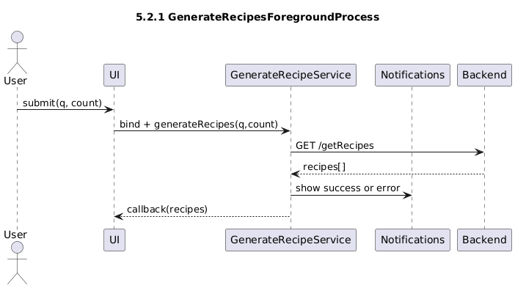

5.2.2. Process 2 Interface — QuotesPeriodicProcess
Field | Description
Trigger | WorkManager schedule
Input | —
Output | Notification with quote; Result.success()
Contracts | Retrofit GET /randomQuote; NotificationUtils

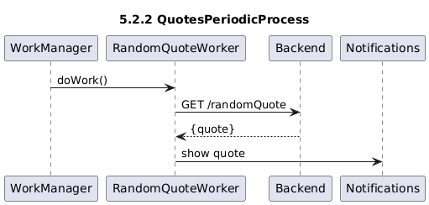

5.2.3. Process 3 Interface — DBConsistencyProcess
Field | Description
Trigger | UI Intent actions
Input | Action-specific (e.g., recipe, ingredient)
Output | ResultReceiver Bundle; broadcasts for state update
Contracts | Room DAOs + UnitConverter; LocalBroadcastManager

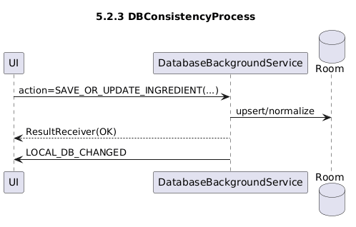

6. Detailed Design

6.1. Modules detailed design

6.1.1. Module 1 — MobileApp (Android/Kotlin)
Field | Description
Name | MobileApp (Android/Kotlin)
Type | Code module
Purpose | Provide UI, orchestrate background work, and persist data locally
Way of operating | Activities/Fragments + ViewModels; Services; Room; Worker
Classes | HomeActivity; GenerateRecipeService; DatabaseBackgroundService; RandomQuoteWorker; SharedPreferencesManager; RecipeDao; IngredientDao; RecipeEntity; IngredientEntity

6.1.1.1. Module 1, class 1 — HomeActivity
Field | Description
Name | HomeActivity
Purpose | Entry activity; sets content view, requests POST_NOTIFICATIONS permission, wires NavController & BottomNavigationView, creates notification channel
Members | requestPermissionLauncher
Methods | onCreate(savedInstanceState: Bundle?)
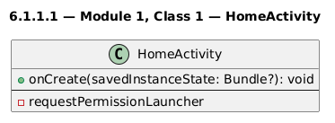

6.1.1.1.1. Module 1, class 1, method 1 — onCreate
Field | Description
Name | onCreate
Purpose | Initialize UI, permissions, navigation, and notification channel
Prototype | fun onCreate(savedInstanceState: Bundle?)
Input | savedInstanceState: Bundle?
Output | —
Caller | Android framework
Calls | findNavController(), setupWithNavController(), NotificationUtils.createNotificationChannel(this), requestPermissionLauncher.launch(...)
Algorithm | Set content view; request POST_NOTIFICATIONS (API 33+); set up bottom navigation with NavController; create notification channel

6.1.1.2. Module 1, class 2 — GenerateRecipeService
Field | Description
Name | GenerateRecipeService
Purpose | Perform recipe generation with dynamic timeout and error notifications
Members | apiService: ApiInterface? ; binder: LocalBinder
Methods | generateRecipes(query, numberOfRecipes, callback); onBind(intent); handleTimeoutException(); handleGenericException(); calculateTimeout(n)
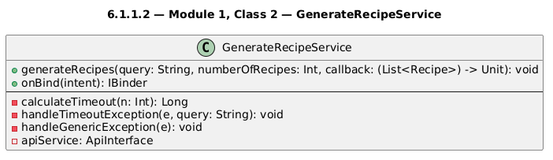

6.1.1.2.1. Module 1, class 2, method 1 — generateRecipes
Field | Description
Name | generateRecipes
Purpose | Issue the network request and deliver parsed recipes to the UI
Prototype | fun generateRecipes(query: String, numberOfRecipes: Int, callback: (List<Recipe>) -> Unit)
Input | query: String ; numberOfRecipes: Int
Output | Invokes callback(List<Recipe>) on main thread
Caller | Home/UI via binding
Calls | ApiClient.getInstance(timeout).create(ApiInterface), ApiInterface.searchRecipes(...).execute()
Algorithm | Compute timeout (5s + 10s/recipe, cap 120s); execute synchronous call on IO; handle SocketTimeoutException and generic exceptions by showing notifications; callback with response body or empty list

6.1.1.3. Module 1, class 3 — DatabaseBackgroundService
Field | Description
Name | DatabaseBackgroundService
Purpose | Encapsulate Room operations and domain rules behind Intent actions
Members | database: AppDatabase
Methods | onCreate(); onStartCommand(...); getSavedRecipes(); getSavedRecipeByName(); saveOrReplaceRecipe(); deleteRecipeByName(); getSavedIngredients(); fetchListedRecipes(); canCookRecipe(); cookRecipe(); getSavedIngredientByNameAndUnit(); saveOrUpdateIngredient(); deleteIngredientByNameAndUnit(); notifyDatabaseChanged()
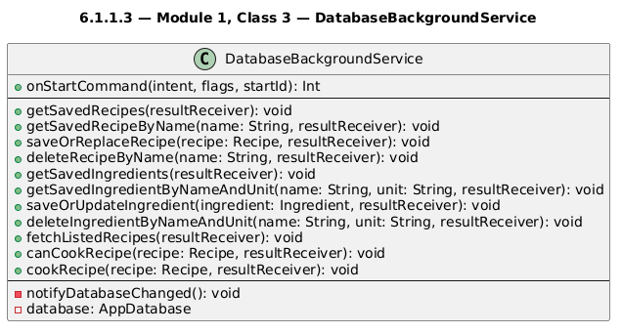

6.1.1.3.1. Module 1, class 3, method 1 — canCookRecipe
Field | Description
Name | canCookRecipe
Purpose | Determine if all required ingredients are available (1% tolerance)
Prototype | private fun canCookRecipe(recipe: Recipe, resultReceiver: ResultReceiver?)
Input | recipe: Recipe
Output | Bundle { canCook:Boolean; missing_ingredients?: ArrayList<Ingredient> } via ResultReceiver
Caller | onStartCommand(action="CAN_COOK_RECIPE")
Calls | ingredientDao.getAllIngredientsSync(), UnitConverter.convert(...)
Algorithm | For each required ingredient: find saved item; convert required amount to saved unit; if required/saved < 0.99, add to missing list; return canCook flag accordingly

6.1.1.3.2. Module 1, class 3, method 2 — cookRecipe
Field | Description
Name | cookRecipe
Purpose | Subtract consumed ingredients from inventory, normalize units; delete when zero
Prototype | private fun cookRecipe(recipe: Recipe, resultReceiver: ResultReceiver?)
Input | recipe: Recipe
Output | Bundle { success:Boolean } via ResultReceiver; broadcast LOCAL_DB_CHANGED
Caller | onStartCommand(action="COOK_RECIPE")
Calls | ingredientDao.getAllIngredientsSync(), UnitConverter.convert(...), UnitConverter.getOptimalUnit(...), ingredientDao.updateIngredient(...), ingredientDao.deleteIngredientByNameAndUnit(...)
Algorithm | For each ingredient: convert to saved unit; subtract; if >0 → normalize to optimal unit and update; else delete row; broadcast DB change

6.1.1.4. Module 1, class 4 — RandomQuoteWorker
Field | Description
Name | RandomQuoteWorker
Purpose | Fetch a random quote and notify user
Members | randomQuoteNotificationId: Int
Methods | doWork(), calculateTimeoutForQuotes(), handleErrorNotification(message)
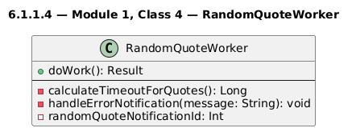

6.1.1.4.1. Module 1, class 4, method 1 — doWork
Field | Description
Name | doWork
Purpose | Execute Retrofit call and display notification
Prototype | override fun doWork(): Result
Input | —
Output | Result.success() after showing notification
Caller | WorkManager runtime
Calls | ApiClient.getInstance(timeout).create(ApiInterface).randomQuote().execute(), NotificationUtils.showStandardNotification(...)
Algorithm | Create client with ~10s timeout; on success show quote; otherwise show error notification; return success

6.1.1.5. Module 1, class 5 — SharedPreferencesManager
Field | Description
Name | SharedPreferencesManager
Purpose | Store settings and broadcast updates
Members | SharedPreferences; constants for keys and ACTION/EXTRAS
Methods | getRandomQuoteFrequency(), saveRandomQuoteFrequency(), getMaxResults(), saveMaxResults(), broadcastSettingsUpdate()

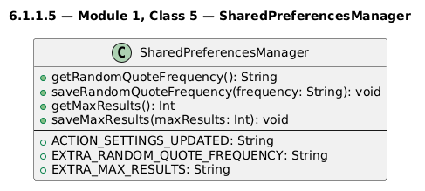

6.1.2. Module 2 — BackendAPI (Node/Express)
Field | Description
Name | BackendAPI (Node/Express)
Type | Process / Code module
Purpose | Serve GET /getRecipes and GET /randomQuote; call OpenAI; return JSON
Way of operating | Express route handlers; JSON responses; uses environment variables for secrets
Classes | Route handlers; schemas module

6.1.2.1. Module 2, class 1 — GET /getRecipes handler
Field | Description
Name | GET /getRecipes
Purpose | Produce normalized list of recipes from a prompt/query using OpenAI
Members | — (route-local variables)
Methods | handler(req,res)

6.1.2.1.1. Module 2, class 1, method 1 — handler(req,res)
Field | Description
Name | handler(req,res)
Purpose | Validate, call OpenAI, map to schema, send JSON
Prototype | (req: Request, res: Response) => void
Input | Query params: numberOfRecipes:int, recipeQuery:string
Output | JSON: { recipes: [...] }
Caller | HTTP client (Mobile app)
Calls | OpenAI client (chat completions/responses)
Algorithm | Read params; build prompt; call OpenAI; validate/normalize; send JSON or error response

6.1.2.2. Module 2, class 2 — GET /randomQuote handler
Field | Description
Name | GET /randomQuote
Purpose | Call OpenAI with quote schema and return {quote}
Members | —
Methods | handler(req,res)

6.1.2.2.1. Module 2, class 2, method 1 — handler(req,res)
Field | Description
Name | handler(req,res)
Purpose | Call OpenAI with quote schema and return {quote}
Prototype | (req: Request, res: Response) => void
Input | —
Output | JSON: { quote: string }
Caller | HTTP client (Worker)
Calls | OpenAI client
Algorithm | Build prompt for concise quote; call OpenAI; send JSON or error

6.2. Data Modules Detailed Design

6.2.1. Data module 1 — RecipeEntity

Field | Description
Name | RecipeEntity
Type | Room Entity (table 'recipes')
Purpose | Persist generated/saved recipes and their listed state.
Way of operating | Used by RecipeDao for CRUD; mapped to/from model Recipe; lists persisted with Gson TypeConverters.
Subordination | AppDatabase.entities; accessed by DatabaseBackgroundService via RecipeDao
Dependencies | Room; GsonConverters; models.Recipe; models.Ingredient
Resources | SQLite (Room)

Attribute | Kotlin Type | Nullability | Default | Notes
title | String | Non-null | — | PRIMARY KEY; unique
estimatedCookingTime | Int | Non-null | 0 | Minutes
servings | Int | Non-null | 1 | Suggested servings
listed | Boolean | Non-null | false | Shopping-list marker
ingredients | List<Ingredient> | Non-null | [] | Serialized via Gson TypeConverter
instructions | List<String> | Non-null | [] | Serialized via Gson TypeConverter

Constraint / Invariant | Description
Title uniqueness | No duplicate 'title' values.
Serializable lists | ingredients and instructions must serialize/deserialize via GsonConverters.
Domain completeness | At least one instruction recommended for UX integrity.

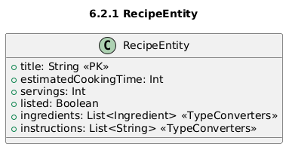

6.2.2. Data module 2 — IngredientEntity
Field | Description
Name | IngredientEntity
Type | Room Entity (table 'ingredients', composite PK: item+unit)
Purpose | Persist inventory items by name+unit with amounts for cooking subtraction and shopping.
Way of operating | Used by IngredientDao for CRUD; model mapping keeps UI decoupled; unit conversions happen at service layer (UnitConverter).
Subordination | AppDatabase.entities; accessed by DatabaseBackgroundService via IngredientDao
Dependencies | Room; models.Ingredient; UnitConverter
Resources | SQLite (Room)

Attribute | Kotlin Type | Nullability | Default | Notes
item | String | Non-null | — | Composite PK (part); lowercased on insert
unit | String | Non-null | — | Composite PK (part); UoM label
amount | Double | Non-null | 0.0 | Quantity in unit; must remain ≥ 0

Constraint / Invariant | Description
Composite key | (item, unit) pair uniquely identifies a row.
Non-negative amount | Zero triggers deletion during 'cook' operations; negatives are invalid.
Unit normalization | Service layer may convert to optimal unit prior to persistence.

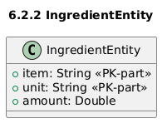

6.2.3 Data module 3 — Recipe (model)
Field | Description
Name | Recipe (model)
Type | Domain model (in-memory)
Purpose | Transport and UI/domain manipulation of data in app layer.
Way of operating | Mapped to/from RecipeEntity using helper functions; transported via Intents/ResultReceiver bundles if needed.
Subordination | Used by UI, services, and DAOs (via mapping).
Dependencies | Kotlin stdlib; mapping helpers; related entity.
Resources | RAM (in-memory)

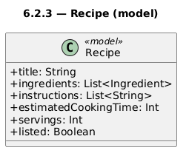

6.2.4 Data module 4 — Ingredient (model)
Field | Description
Name | Ingredient (model)
Type | Domain model (in-memory)
Purpose | Transport and UI/domain manipulation of data in app layer.
Way of operating | Mapped to/from IngredientEntity using helper functions; transported via Intents/ResultReceiver bundles if needed.
Subordination | Used by UI, services, and DAOs (via mapping).
Dependencies | Kotlin stdlib; mapping helpers; related entity.
Resources | RAM (in-memory)

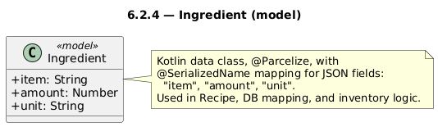

6.2.5 Data module 5 — RecipeDao (DAO)
Field | Description
Name | RecipeDao
Type | Data Access Object (Room DAO)
Purpose | CRUD access for RecipeEntity
Way of operating | Suspend functions executed on IO dispatcher; Room generates implementation.
Subordination | Exposed via AppDatabase; consumed by services.
Dependencies | Room; RecipeEntity
Resources | SQLite (Room)

Method | Annotation | SQL | Parameters | Returns | Purpose
getAllRecipesSync | Query | SELECT * FROM recipes | — | List<RecipeEntity> | Fetch all rows
getRecipeByNameSync | Query | SELECT * FROM recipes WHERE title = :name | name: String | RecipeEntity? | Fetch rows by constraint
getListedRecipes | Query | SELECT * FROM recipes WHERE listed= 1 | — | List<RecipeEntity> | Fetch rows by constraint

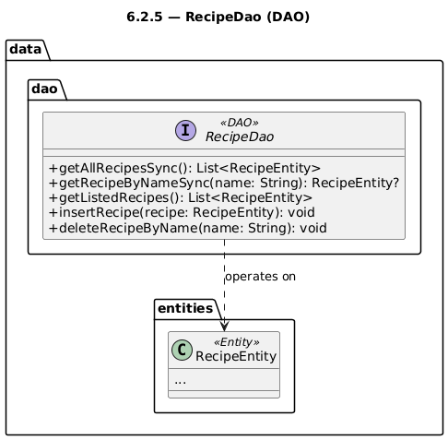

6.2.6 Data module 6 — IngredientDao (DAO)
Field | Description
Name | IngredientDao
Type | Data Access Object (Room DAO)
Purpose | CRUD access for IngredientEntity
Way of operating | Suspend functions executed on IO dispatcher; Room generates implementation.
Subordination | Exposed via AppDatabase; consumed by services.
Dependencies | Room; IngredientEntity
Resources | SQLite (Room)

Method | Annotation | SQL | Parameters | Returns | Purpose
getAllIngredientsSync | Query | SELECT * FROM ingredients | — | List<IngredientEntity> | Fetch all rows
getIngredientByNameAndUnitSync | Query | SELECT * FROM ingredients WHERE item = :name AND unit = :unit | name: String, unit: String | IngredientEntity? | Fetch rows by constraint

a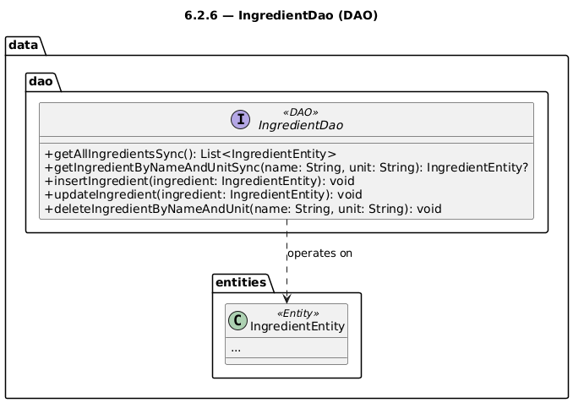

Appendices

A1. Use cases diagrams
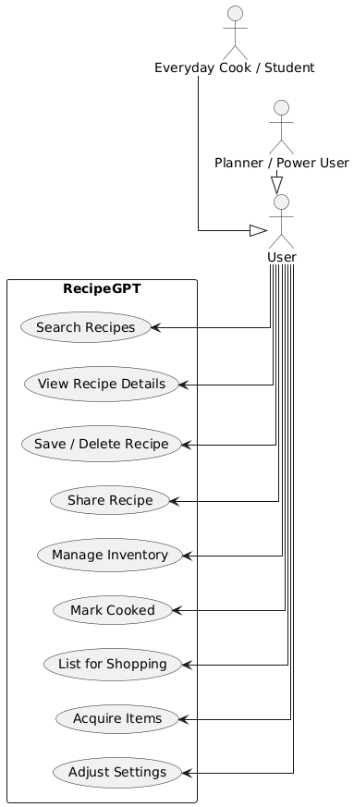

A2. Class diagrams
- Home Activity
- Generate Recipe Service
- DataBase Background Service

- Random Quote Worker
- Shared Preferences Manager
- Recipe Entity
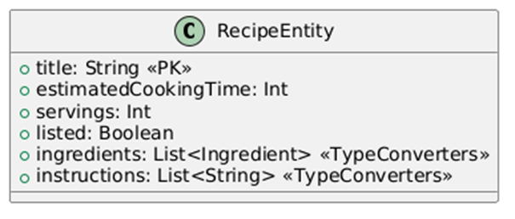
- Ingredient Entity
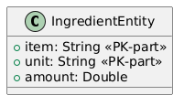

- Recipe (Model)
- Ingredient (Model)
- RecipeDAO

- Ingredient DAO

A3. Sequence diagrams
- Random Quote

- Generate Recipes

- Android Runtime Interactions

- Cook Recipe

- Generate Recipes Foreground Process

- Quote Period Process

- DB Consistency Process

A4. Document evolution
A4.1 Initial design snapshot
Initial design matched the SRS: thin Node/Express backend exposing recipe and quote endpoints, and an Android client handling search, basic recipe storage, and a simple ingredient list. Room, WorkManager and notifications were mentioned but not fully structured into explicit entities, DAOs, or processes.
A4.2 Major changes list by date
- 2025-10 – Introduced RecipeEntity / IngredientEntity and RecipeDao / IngredientDao; added mappings from Recipe / Ingredient models.
- 2025-10 – Added DatabaseBackgroundService, GenerateRecipeService, and first version of RandomQuoteWorker for background work and notifications.
- 2025-11 – Formalized unit handling with QuantUnit and UnitConverter in canCookRecipe / cookRecipe; clarified inventory invariants.
- 2025-11 – Expanded dependency and interface sections; documented all IPC mechanisms (Intents, ResultReceiver, LocalBroadcastManager, notifications).
- 2025-11 – Updated SDD to follow IEEE 1016 more strictly, added PlantUML class/sequence diagrams, and converted descriptions to tables.
A4.3 Current state summary
Android app now has clear modules, entities, models, and DAOs, with Room-based persistence and background work via services + WorkManager. The backend remains AI-only, providing GET /getRecipes and GET /randomQuote with structured JSON. Constraints: internet required for generation/quotes; reliance on OpenAI and backend uptime. Next steps: strengthen tests, refine error/timeout handling, and add better filtering/pagination for recipes and ingredients.

A5. Conclusions regarding the activity
Architectural Summary
RecipeGPT uses a deliberately thin, stateless backend and a feature-rich Android client. The backend focuses on validating requests, calling the OpenAI API, and returning normalized JSON responses, while the mobile app handles domain logic, user interaction, and local data storage.
Qualities and Future Evolution
On the client side, Room, WorkManager, and a clear notification strategy ensure offline access, background processing, and continuous user feedback. This separation of concerns—lightweight server and robust client—improves performance, resilience, and maintainability, and leaves room for future extensions such as richer filters, new endpoints, or more advanced personalization features.

